**1)Explain any 5 elements or components of a building?**

**The following are the basic elements of a building:**

**1. Foundation**

**2. Plinth**

**3. Walls and columns**

**4. Sills, lintels and chajjas**

**5. Doors and windows**

**6. Floors**

**7. Roofs**

**8. Steps, stairs and lifts**

**9. Finishing work**

**10. Building services.**

**1. Foundation: Foundation is the most important part of the building. Building activity starts with digging the ground for foundation and then building it. It is the lower most part of the building. It transfers the load of the building to the ground. Its main functions and requirements are:**

**(a) Distribute the load from the structure to soil evenly and safely.**

**(b) To anchor the building to the ground so that under lateral loads building will not move.**

**(c) It prevents the building from overturning due to lateral forces.**

**(d) It gives level surface for the construction of super structure.**

**2. Plinth: The portion of the wall between the ground level and the ground floor level is called plinth. It is usually of stone masonry. If the foundation is on piles, a plinth beam is cast to support wall above floor level. At the top of plinth a damp proof course is provided. It is usually 75 mm thick plain concrete course. The function of the plinth is to keep the ground floor above ground level, free of dampness. Its height is not less than 450 mm. It is required that plinth level is at least 150 mm above the road level, so that connections to underground drainage system can be made.**

**3. Walls and Columns: The function of walls and columns is to transfer the load of the structure vertically downwards to transfer it to foundation. Apart from this wall performs the following functions also:**

**(a) It encloses building area into different compartments and provides privacy.**

**(b) It provides safety from burglary and insects.**

**(c) It keeps the building warm in winter and cool in summer.**

**4. Sills, Lintels and Chajjas: A window frame should not be directly placed over masonry. It is placed over 50 mm to 75 mm thick plain concrete course provided over the masonry. This course is called as sill. Lintels are the R.C.C. or stone beams provided over the door and window openings to transfer the load transversely so as to see that door or window frame is not stressed unduly. Chajja is the projection given outside the wall to protect doors and windows from the rain. They are usually made with R.C.C. The projection of chajja varies from 600 mm to 800 mm.**

**5. Doors and Windows: The function of a door is to give access to different rooms in thebuilding and to deny the access whenever necessary. Number of doors should be minimum possible. The size of the door should be of such dimension as will facilitate the movement of the largest object likely to use the door. Windows are provided to get light and ventilation in the building. They are located at a height of 0.75 m to 0.9 m from the floor level. In hot and humid regions, the window area should be 15 to 20 per cent of the floor area. Another thumb rule used to determine the size and the number of windows is for every 30 m3of inside volume there should be 1 m2 window opening.**

**6. Floors: Floors are the important component of a building. They give working/useful area for the occupants. The ground floor is prepared by filling brick bats, waste stones, gravel and well compacted with not less than 100 mm sand layer on its top. A lean concrete of 1 : 4 : 8, 100 mm thick is laid. On this a damp proof course may be provided. Then floor finishing is done as per the requirement of the owner. Cheapest floor finish for a moderate house is with 20 to 25 mm rich mortar course finished with red oxide. The costliest floor finish is mosaic or marble finishing.**

**7. Roof: Roof is the top most portion of the building which provide top cover to the building. It should be leak proof. Sloping roof like tiled and A.C sheet give leak proof cover easily. But they do not give provision for the construction of additional floor. Tiled roof give good thermal protection. Flat roofs give provision for additional floors. Terrace adds to the comfort of occupants. Water tanks can be easily placed over the flat roofs.**

**8. Step, Stairs and Lifts: Steps give convenient access from ground level to ground floor level. They are required at doors in the outer wall 250 to 300 mm wide and 150 mm rise is ideal size for steps. In no case the size of two consecutive steps be different. Number of steps required depends upon the difference in the levels of the ground and the floor. Stairs give access from floor to floor. They should consists of steps of uniform sizes. In all public buildings lifts are to be provided for the conveniences of old and disabled persons. In hostels G + 3 floors can be built without lifts, but in residential flats maximum floors permitted without lifts is only G + 2. Lift is to be located near the entrance. Size of the lift is decided by the number of users in peak hours. Lifts are available with capacity 4 to 20 persons.**

**9. Finishing: Bottom portion of slab (ceiling), walls and top of floor need smooth finishing with plaster. Then they are provided with white wash, distemper or paints or tiles. The function of finishing work is:**

**(a) Give protective cover**

**(b) Improve aesthetic view**

**(c) Rectify defective workmanship**

**(d) Finishing work for plinth consists in pointing while for floor it consists in polishing.**

**10. Building Services: Water supply, sanitation and drainage works, electric supply work and construction of cupboards and show cases constitute major building services. For storing water from municipal supply or from tanker a sump is built in the house property near street. From the sump water is pumped to over head tanks placed on or above roof level so as to get water all the 24 hours. Plumbing work is made so as to get water in kitchen, bathrooms, water closets, sinks and garden taps. For draining rain water from roofs, down take pipes of at least 100 mm diameters should be used. Proper slopes should be given to roof towards down take pipe. These pipes should be fixed at 10 to 15 mm below the roof surface so that rain water is directed to the down take pipe easily. The sanitary fittings are to be connected to stone ware pipes with suitable traps and chambers. Stone ware pipes are then connected to underground drainage of municipal lines or to the septic tank. Many carpentry works are required for building service. They are in the form of showcases, cupboards, racks etc. Electric supply is essential part of building services. The building should be provided with sufficient points for supply of lights, fans and other electric gadgets.**

**2) Explain the functions of various ingredients of concrete.**

**Cement is the binding material. After addition of water it hydrates and binds aggregates and the surrounding surfaces like stone and bricks. Generally richer mix (with more cement) gives more strength. Setting time starts after 30 minutes and ends after 6 hours. Hence concrete should be laid in its mould before 30 minutes of mixing of water and should not be subjected to any external forces till final setting takes place.**

**Coarse aggregate consists of crushed stones. It should be well graded and the stones should be of igneous origin. They should be clean, sharp, angular and hard. They give mass to the concrete and prevent shrinkage of cement.**

**Fine aggregate consists of river sand. It prevents shrinkage of cement. When surrounded by cement it gains mobility enters the voids in coarse aggregates and binding of ingredients takes place. It adds density to concrete, since it fills the voids. Denser the concrete higher is its strength.**

**Water used for making concrete should be clean. It activates the hydration of cement and forms plastic mass. As it sets completely concrete becomes hard mass. Water gives workability to concrete which means water makes it possible to mix the concrete with ease and place it in final position. More the water better is the workability. However excess water reduces the strength of concrete. To achieve required workability and at the same time good strength a water cement ratio of 0.4 to 0.45 is used, in case of machine mixing and water cement ratio of 0.5 to 0.6 is used for hand mixing.**

**3) State the different possesses involved in the Preparation and placing of concrete.**

**The following steps are involved in the concreting:**

**1. Batching**

**2. Mixing**

**3. Transporting and placing and**

**4. Compacting**

**1. Batching: The measurement of materials for making concrete is known as batching. The**

**following two methods of batching is practiced:**

**(a) Volume batching**

**(b) Weight batching**

**(a) Volume Batching: In this method cement, sand and concrete are batched by volume. A gauge box is made with wooden plates, its volume being equal to that of one bag of cement. One bag of cement has volume of 35 litres. The required amount of sand and coarse aggregate is added by measuring on to the gauge box. The quantity of water required for making concrete is found after deciding water cement ratio. For example, if water cement ratio is 0.5, for one bag of cement (50 kg), water required is 0.5 × 50 = 25 kg, which is equal to 25 litres. Suitable measure is used to select required quantity of water. Volume batching is not ideal method of batching. Wet sand has higher volume for the same weight of dry sand. It is called bulking of sand. Hence it upsets the calculated volume required.**

**(b) Weight Batching: This is the recommended method of batching. A weighing platform isused in the field to pick up correct proportion of sand and coarse aggregates. Large weigh batching plants have automatic weighing equipments.**

**2. Mixing: To produce uniform and good concrete, it is necessary to mix cement, sand andcoarse aggregate, first in dry condition and then in wet condition after adding water.**

**The following methods are practiced:**

**(a) Hand Mixing**

**(b) Machine Mixing.**

**(a) Hand Mixing: Required amount of coarse aggregate for a batch is weighed and is spread on an impervious platform. Then the sand required for the batch is spread over coarse aggregate. They are mixed in dry condition by overturning the mix with shovels. Then the cement required for the batch is spread over the dry mix and mixed by shovels. After uniform texture is observed water is added gradually and mixing is continued. Full amount of water is added and mixing is completed when uniform colour and consistency is observed. The process of mixing is completed in 6–8 minutes of adding water. This method of mixing is not very good but for small works it is commonly adopted.**

**b) Machine Mixing: In large and important works machine mixing is preferred. Figure 3.2 shows a typical concrete mixer. Required quantities if sand and coarse aggregates are placed in the drum of the mixer. 4 to 5 rotations are made for dry mixing and then required quantity of cement is added and dry mixing is made with another 4 to 5 rotations. Water is gradually added and drum is rotated for 2 to 3 minutes during which period it makes about 50 rotations. At this stage uniform and homogeneous mix is obtained.**

**3. Transporting and Placing of Concrete. After mixing concrete should be transported to the final position. In small works it is transported in iron pans from hand to hand of a set of workers. Wheel barrow and hand carts also may be employed. In large scale concreting chutes and belt conveyors or pipes with pumps are employed. In transporting care should be taken to see that segregation of aggregates from matrix of cement do not take place. Concrete is placed on form works. The form works should be cleaned and properly oiled. If concrete is to be placed for foundation, the soil bed should be compacted well and is made free from loose soil. Concrete should be dropped on its final position as closely as possible. If it is dropped from a height, the coarse aggregates fall early and then mortar matrix. This segregation results into weaker concrete.**

**4. Compaction of Concrete: In the process of placing concrete, air is entrapped. The entrapped air reduces the strength of concrete up to 30%. Hence it is necessary to remove this entrapped air. This is achieved by compacting the concrete after placing it in its final position. Compaction can be carried out either by hand or with the help of vibrators.**

**(a) Hand Compaction: In this method concrete is compacted by ramming, tamping, spading or by slicing with tools. In intricate portions a pointed steel rod of 16 mm diameter and about a metre long is used for poking the concrete.**

**(b) Compaction by Vibrators: Concrete can be compacted by using high frequency vibrators. Vibration reduces the friction between the particles and set the motion of particles. As a result entrapped air is removed and the concrete is compacted. The use of vibrators reduces the compaction time. When vibrators are used for compaction, water cement ratio can be less, which also help in improving the strength of concrete. Vibration should be stopped as soon as cement paste is seen on the surface of concrete. Over vibration is not good for the concrete.**

**The following types of vibrators are commonly used in concreting:**

**(a) Needle or immersion vibrators**

**(b) Surface vibrators**

**(c) Form or shutter vibrators**

**(d) Vibrating tables.**

**Needle vibrators are used in concreting beams and columns. Surface vibrators and form vibrators are useful in concreting slabs. Vibrating tables are useful in preparing precast concrete elements.**

**4)State the different methods of curing.**

**Curing may be defined as the process of maintaining satisfactory moisture and temperature conditions for freshly placed concrete for some specified time for proper hardening of concrete. Curing in the early ages of concrete is more important. Curing for 14 days is very important. Better to continue it for 7 to 14 days more. If curing is not done properly, the strength of concrete reduces. Cracks develop due shrinkage. The durability of concrete structure reduces.**

**The following curing methods are employed:**

**(a) Spraying of water**

**(b) Covering the surface with wet gunny bags, straw etc.**

**(c) Ponding**

**(d) Steam curing and**

**(e) Application of curing compounds.**

**(a) Spraying of water: Walls, columns, plastered surfaces are cured by sprinkling water.**

**(b) Wet covering the surface: Columns and other vertical surfaces may be cured by covering the surfaces with wet gunny bags or straw.**

**(c) Ponding: The horizontal surfaces like slab and floors are cured by stagnating the water to a height of 25 to 50 mm by providing temporary small bunds with mortar.**

**(d) Steam curing: In the manufacture of pre-fabricated concrete units steam is passed over the units kept in closed chambers. It accelerates curing process, resulting into the reduction of curing period.**

**(e) Application of curing compounds: Compounds like calcium chloride may be applied onthe curing surface. The compound shows affinity to the moisture and retains it on the surface. It keeps the concrete surface wet for a long time.**

**5) State the uses of RCC.**

**Uses of R.C.C.**

**It is a widely used building material. Some of its important uses are listed below:**

**1. R.C.C. is used as a structural element, the common structural elements in a building where R.C.C. is used are:**

**(a) Footings (b) Columns (c) Beams and lintels (d) Chajjas, roofs and slabs. (e) Stairs.**

**2. R.C.C. is used for the construction of storage structures like**

**(a) Water tanks (b) Dams (c) Bins (d) Silos and bunkers.**

**3. It is used for the construction of big structures like**

**(a) Bridges (b) Retaining walls (c) Docks and harbours (d) Under water structures.**

**4. It is used for pre-casting**

**(a) Railway sleepers (b) Electric poles**

**5. R.C.C. is used for constructing tall structures like**

**(a) Multi-storey buildings (b) Chimneys (c) Towers.**

**6. It is used for paving (a) Roads (b) Airports.**

**7. R.C.C. is used in building atomic plants to prevent danger of radiation. For this purpose R.C.C. walls built are 1.5 m to 2.0 m thick.**

**6)Explain the difference between load bearing and Framed structure.**

|  |  |  |
| --- | --- | --- |
| **Sr. No** | **Load bearing structure** | **Framed structure** |
| **1** | **Cost is less** | **Cost is more** |
| **2** | **Suitable up to 3 storeys** | **Suitable for any number of storeys** |
| **3** | **Walls are thicker hence floor area is reduced.** | **Walls are thinner hence more floor area is available for use.** |
| **4** | **Slow construction** | **Speedy construction** |
| **5** | **Not possible to alter the position of walls**  **after construction** | **Position of walls maybe changed**  **whenever necessary** |
| **6** | **Resistance to earthquake is poor** | **Resistance to earthquake is good** |

**7)Explain any five types of shallow foundations with the help of a neat diagram.**

**Shallow foundations: When the depth of the foundation is less than or equal to its width, the foundation is known as shallow foundation. Eg Spread footing, Combined footing, continuous footing, raft foundation etc. Deep foundations: When the depth of the foundation is much higher compared to the it’s width, it’s known as deep foundation. Eg Well foundation, pile foundation.**

1. **Spread Footings: This type of foundations are commonly used for walls and masonry columns. These foundations are built after opening the trenches to required depth. Such footings are economical up to a maximum depth of 3 m. As these foundations are suitable depth, they are grouped under shallow foundations. Before building these footing trenches are opened to required depth and the soil is rammed well. Then a plain concrete of mix 1 : 4 : 8 is provided. Its thickness varies from 150 to 200 mm. Over this bed, stone masonry footing is built. It is built in courses each course projecting 50 to 75 mm from the top course and height of each course being 150 to 200 mm. In case of wall footing the projections are only one direction while in case of columns, they are in both directions. The projection of bed concrete from the lowest course of foundation masonry is usually 150 mm.**

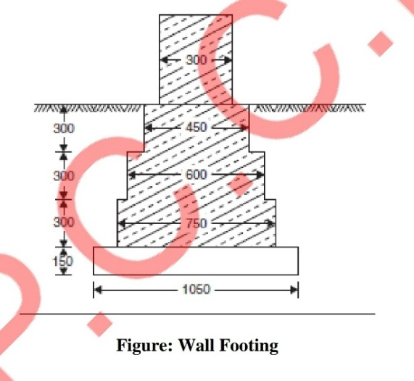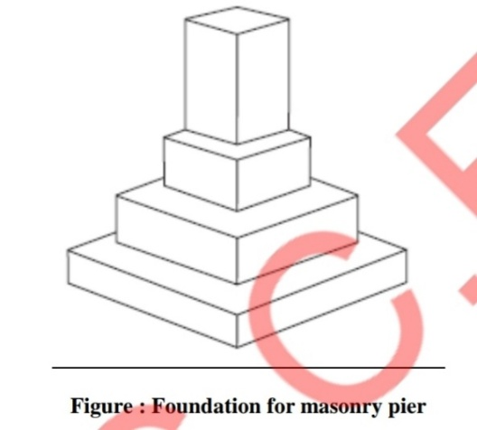

**2. RCC Footings**

**There are mainly two types of R.C.C. footings:**

**1. One way reinforced footings.**

**2. Two way reinforced footings**

**1. One Way Reinforced Footing: These footings are for the walls. In these footings main**

**reinforcements are in the transverse direction of wall. In longitudinal directions there will be**

**only nominal reinforcement.**

**2. Two Way Reinforced Footings: For columns two way reinforced footings are provided.**

**The following types of the footings are common:**

**(i) Isolated Column Footings: If separate footings are provided for each column, it is called**

**isolated column footing. The size of footing is based on the area required to distribute the**

**load of the columns safely over the soil . These footings are provided over a 100 to 150 mm**

**bed concrete. Required reinforcements and thickness of footing are found by the design**

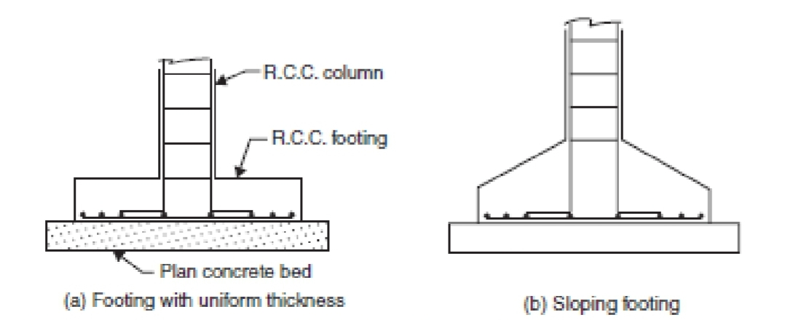**engineers. Thickness may be uniform or varying.**

**(ii) Combined Footings: Common footings may be provided for two columns. This type of**

**footing is necessary when a column is very close to the boundary of the property and hence**

**there is no scope to project footing much beyond the column face. The footing is to be**

**designed for transferring loads from both columns safely to the soil. The two columns may or**

**may not be connected by a strap beam.**

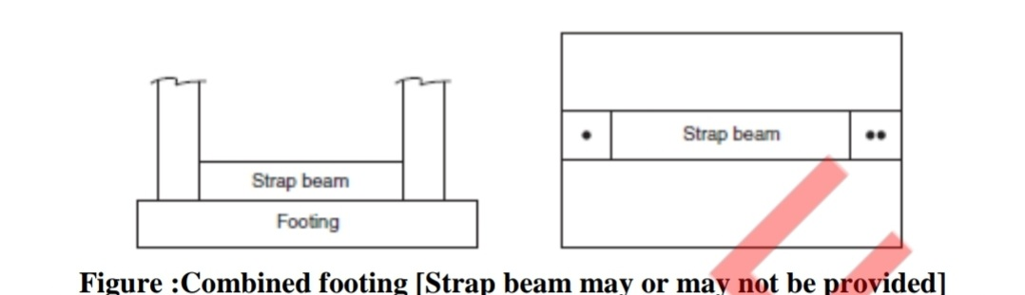

**(iii) Continuous Footings: If a footing is common to more than two columns in a row, it is**

**called continuous footing. This type of footing is necessary, if the columns in a row are closer**

**or if SBC of soil is low.**

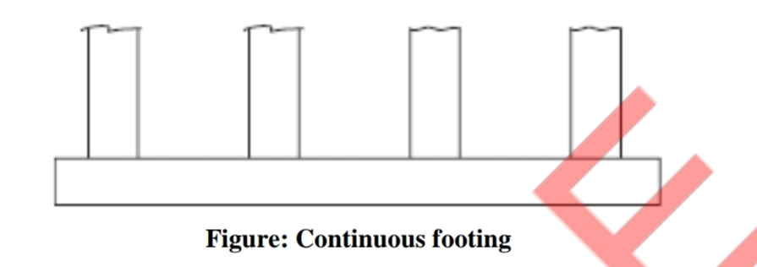

**(iv) Mat Footing/Raft Footing: If the load on the column is quite high (Multi-storey**

**columns) or when the SBC of soil is low, the sizes of isolated columns may work out to be to**

**such an extent that they overlap each other. In such situation a common footing may be**

**provided to several columns. Such footings are known as raft footings. If the beams are**

**provided in both directions over the footing slab for connecting columns, the raft foundations**

**may be called as grid foundation also. The added advantage of such footing is, settlement is**

**uniform and hence unnecessary stresses are not produced**

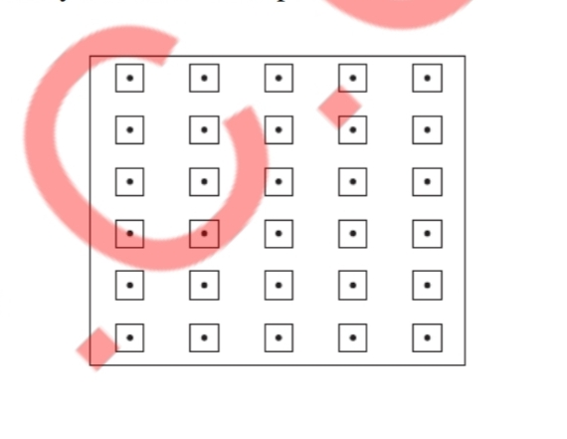

**GRILLAGE FOOTING**

**High rise buildings are built with steel columns encased in concrete. Such columns carry very**

**heavy load and hence they need special foundations to spread the load to a larger area of soil.**

**Grillage foundation is one such special foundation. It consists of one tier or more tiers of I-**

**sections steel beams. Top tier consists of less number but large size steel section while lower**

**tier consists of larger number but smaller size steel sections. Column load is transferred to**

**the top tier through a base plate. The grillage beams are unpainted and are encased in**

**concrete with minimum cover of 100 mm beyond the edges of steel sections. A minimum**

**clear space of 75 mm should be maintained between the flanges of adjacent grillage beams so**

**that concreting can be made properly. To maintain spacing, pipe separators are used.**

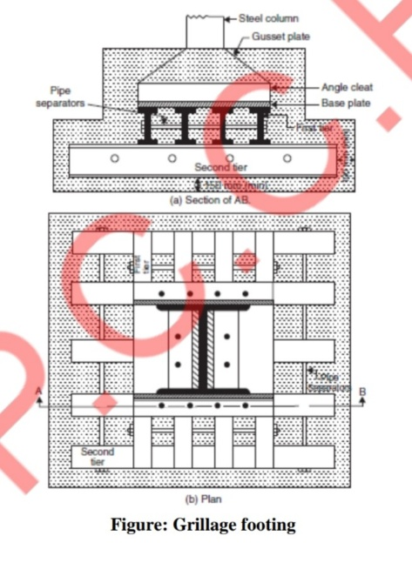**Arch foundation**

**Inverted arch foundations are provided in the places where the SBC of the soil is very poor**

**and the load of the structure is through walls. In such cases inverted arches are constructed**

**between the walls. End walls should be sufficiently thick and strong to withstand the outward**

**horizontal thrust due to arch action. The outer walls may be provided with buttress walls to**

**strengthen them.**

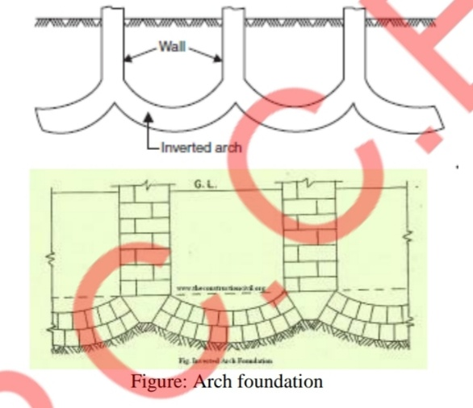

**8)Explain the different types of brick bonds with the help of neat sketches.**

**The various types of bonds generally used in brick masonry**

**are:**

**1. Stretcher bond**

**2. Header bond**

**3. English bond and**

**4. Flemish bond.**

**1. Stretcher Bond: A stretcher is the longer face of the brick as seen in the**

**elevation. In the brick of size 190 mm × 90 mm × 90 mm, 190 mm × 90 mm**

**face is the stretcher. In stretcher bond masonry all the bricks are arranged in**

**stretcher courses. However care should be taken to break vertical joints. This**

**type of construction is useful for the construction half brick thick partition wall.**

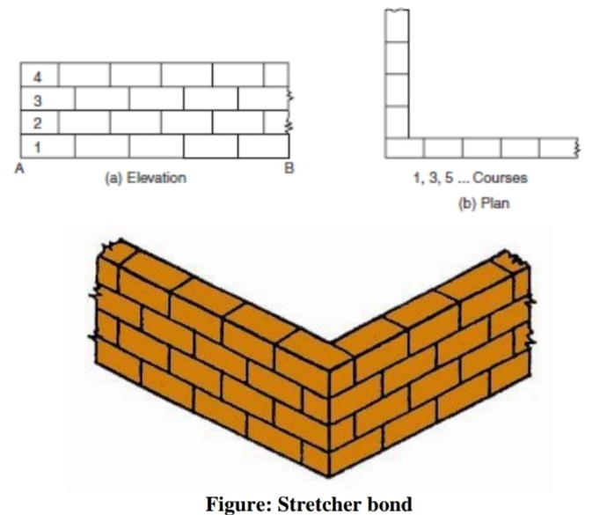

**2. Header Bond: A header is the shorter face of the brick as seen in the**

**elevation. In a standard brick it is 90 mm × 90 mm face. In header bond brick**

**masonry all the bricks are arranged in the header courses. This type of bond is**

**useful for the construction of one brick thick walls.**

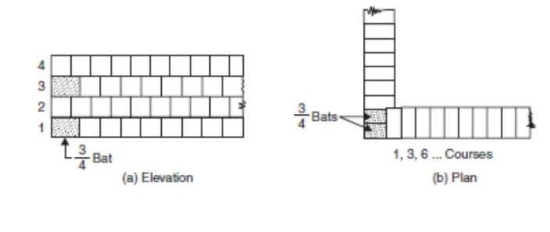

**3. English Bond: In this alternate courses consist of headers and stretchers.**

**This is considered to be the strongest bond. Hence it is commonly used bond for**

**the walls of all thicknesses. To break continuity of vertical joints a brick is cut**

**lengthwise into two halves and used in the beginning and end of a wall after**

**first header. This is called queen closer. Figure shows typical one brick and one**

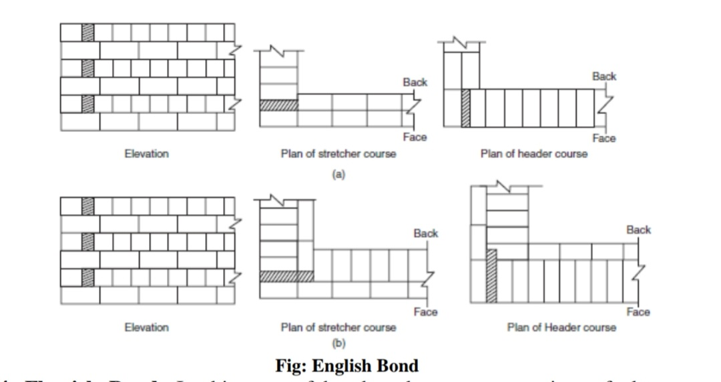**and half brick thick wall with English bond.**

**4. Flemish Bond: In this type of bond each course comprises of alternate**

**header and stretcher. Alternate courses start with stretcher and header. To break**

**the vertical joints queen closers are required, if a course starts with header.**

**Every header is centrally supported on the stretcher below it.**

**Flemish bonds may be further classified as**

**(a) Double Flemish Bond**

**(b) Single Flemish Bond.**

**In case of Double Flemish bond, both faces of the wall have Flemish look, i.e.**

**each course consist of alternate header and stretcher, whereas single Flemish**

**bond outer faces of walls have Flemish look whereas inner faces have look of**

**English bond. Construction of Flemish bond needs greater skill. It gives more**

**pleasing appearance. But it is not as strong as English bond. If only pointing is to be used for finished wall, Flemish bond may be used to get good aesthetic**

**view. If plastering is going to be used, it is better to use English bond.**

**9)State the advantages of lean Construction practices.**

**Advantages:**

**1.Using fewer materials and having less waste can greatly reduce all**

**around costs. Although the philosophy of lean construction is focused**

**on overall reduction, not just for profit, utilizing this methodology has**

**shown to increase the bottom line.**

**2.Construction time can greatly be reduced by increased planning and**

**strategic vision.**

**3.Fewer accidents and a higher rate of safety through increased worker**

**focus and understanding.**

**4.Increased schedule reliability and predictability.**

**5.Improved overall results due to increased communication and fewer**

**workers.**

**6.Decreased stress for workers and management due to fewer workers.**

**7.Increased productivity all around due to a higher rate of planning.**

**8.Increased profits and turnovers, with increased customer**

**satisfaction.**

**9.Increased worker accountability.**

**10. Increased job satisfaction resulting in more performance commitment.**

**10)Explain the use of automation and robotics in civil engineering**

**1. It increases labour productivity and reduces labour cost.**

**2. It also mitigates the effects of labour shortages.**

**3. It reduces or eliminates routine manual and clerical tasks.**

**4. It helps in improving worker safety and efficiency.**

**5. It gives a better product quality and reduced manufacturing lead time.**

**6. Processes that cannot be done manually are accomplished using**

**automation and robots.**

**7. Automating construction process is necessary in order to reduce**

**production times.**

**8. With automation, dangerous work can be avoided for manual labour.**

**9. It does the work, people cannot do easily, and increases the performance.**

**10.Automation gives quality construction.**

**11.With automation the measurement are more accurate ;the weighing and**

**proportion of mixing ingredients is better.**

**12.Since India has second largest manpower in the world, automation is not**

**replacements of human power but is an important supplement that caters**

**to the need of mega construction and fast-track construction.**

**13.The problems associated with constructed work such as decreasing quality**

**of work, labour shortages, etc. Can be overcome by new innovative**

**technologies such as automation which has the potential to improve the**

**quality, safety, productivity of the construction industry.**

**14.The importance of implementing automation technologies is the need of**

**today's infrastructure project and construction firms in order to increase**

**the productivity and good quality of work.**

**11)Explain the use of any 5 construction equipments.**

**1. EXCAVATORS**

**Excavators are important and widely used equipment in construction**

**industry. Their general purpose is excavation but other than that they are**

**also used for many purposes like heavy lifting, demolition, river**

**dredging, cutting of trees etc. Excavators contains a long arm and a**

**cabinet. At the end of long arm digging bucket is provided and cabinet is**

**the place provided for machine operator. This whole cabin arrangement**

**can be rotatable up to 360o which eases the operation. Excavators are**

**available in both wheeled and tracked forms of vehicles.**

**2. Backhoe**

**Backhoe is another widely used equipment which is suitable for multiple**

**purposes. The name itself tells that the hoe arrangement is provided on the back**

**side of vehicle while loading bucket is provided in the front. This is well useful**

**for excavating trenches below the machine level and using front bucket;**

**loading, unloading and lifting of materials can be done.**

**3. Dragline Excavator**

**Dragline excavator is another heavy equipment used in construction which is**

**generally used for larger depth excavations. It consists a long length boom and**

**digging bucket is suspended from the top of the boom using cable. For the**

**construction of ports, for excavations under water, sediment removal in water**

**bodies etc. can be done by dragline excavator.**

**4. Bulldozers**

**Bulldozers are another type of soil excavating equipment which are used to**

**remove the topsoil layer up to particular depth. The removal of soil is done by**

**the sharp edged wide metal plate provided at its front. This plate can be lowered**

**and raised using hydraulic pistons. These are widely used for the removal of**

**weak soil or rock strata, lifting of soil etc.**

**5. Graders**

**Graders also called as motor graders are another type of equipment used in**

**construction especially for the construction of roads. It is mainly used to level**

**the soil surface. It contains a horizontal blade in between front and rear wheels**

**and this blade is lowered in to the ground while working. Operating cabin is**

**provided on the top of rear axle arrangement. Motor Graders are also used to**

**remove snow or dirt from the roads, to flatten the surface of soil before laying**

**asphalt layer, to remove unnecessary soil layer from the ground etc**

**6. Wheel Tractor Scraper**

**Wheel Tractor Scrapers are earth moving equipment used to provide flatten soil**

**surface through scrapping. Front part contains wheeled tractor vehicle and rear**

**part contain a scrapping arrangement such as horizontal front blade, conveyor**

**belt and soil collecting hopper. When the front blade is lowered onto the ground**

**and vehicle is moved, the blade starts digging the soil above the blade level and**

**the soil excavated is collected in hopper through conveyor belt. When the**

**hopper is full, the rear part is raised from the ground and hopper is unloaded at**

**soil dump yard.**

**7. Trenchers**

**Trenchers or Trenching machines are used to excavate trenches in soil. These**

**trenches are generally used for pipeline laying, cable laying, drainage purposes**

**etc. Trenching machines are available in two types namely chain trenchers and**

**wheeled trenchers. Chain trenchers contains a fixed long arm around which**

**digging chain is provided. Wheeled trenchers contains a metal wheel with**

**digging tooth around it. To excavate hard soil layers, wheeled trenchers are**

**more suitable. Both types of trenchers are available in tracked as well as**

**wheeled vehicle forms.**

**8. Loaders**

**Loaders are used in construction site to load the material onto dumpers, trucks**

**etc. The materials may be excavated soil, demolition waste, raw materials, etc.**

**A loader contain large sized bucket at its front with shorter moving arm.**

**Loader may be either tracked or wheeled. Wheeled loaders are widely used in**

**sites while tracked or crawled loaders are used in sites where wheeled vehicles**

**cannot reach .**

**9. Tower Cranes**

**Tower cranes are fixed cranes which are used for hoisting purposes in**

**construction of tall structures. Heavy materials like pre-stressed concrete**

**blocks, steel trusses, frames etc. can be easily lifted to required height using this**

**type of equipment. They consists mast which is the vertical supporting tower,**

**Jib which is operating arm of crane, counter jib which is the other arm carries**

**counter weight on rear side of crane and an operator cabin from which the crane**

**can be operated.**

**10. Tippers**

**A truck or lorry the rear platform of which can be raised at the front end to**

**allow the load to be discharged by gravity also called tip truck. Tippers are**

**suited for the rough and tumble of mining & quarrying operations, as well as for**

**carrying bulk loads in construction and infrastructure industries. Complete**

**manoeuvrability, high performance and long-term endurance are common to all**

**trucks, resulting in lower operational costs.**

**11. Dumpers**

**A dump truck is a vehicle designed to transport bulk material, often in**

**construction. It has a open jump ahead with the driver seat , and consist of a**

**large boxlike body to contain materials. A dumper usually has 4 Wheels, where**

**the entire load and the movement depends on. The jump can tipped to be the**

**load dump; This is where the name “dumper” comes. They are usually diesel**

**engine. Modern dumpers have payloads up to 10 tons and usually articulate**

**perform in the middle of the housing. There are various sizes of dumpers in the**

**present construction industry. Apart from using them for construction, they are**

**also been used in Large mining tunnels and gem excavations to remove soil and**

**other substances.**

**12. Trailer**

**The term trailer refers to such vehicles used for transport of goods and**

**materials in construction or other related field. It is commonly used for the**

**transport of goods and materials. Sometimes recreational vehicles, travel**

**trailers, or mobile homes with limited living facilities, where people can camp**

**or stay have been referred to as trailers.**

**13. Tanker**

**A tank truck or road tanker is a motor vehicle designed to carry liquefied loads,**

**dry bulk cargo or gases on roads. The largest such vehicles are similar to**

**railroad tank cars which are also designed to carry liquefied loads. Many**

**variants exist due to the wide variety of liquids that can be transported. In**

**construction its use for carrying concrete mixed.**

**14. Crane**

**A crane is a type of machine commonly used in construction, generally**

**equipped with an elevator, ropes or chains and sheaves that can be used both to**

**move and to lift and lower materials horizontally. It is mainly used for heavy**

**lifting and transport to other locations. One or more simple machines are used to**

**provide a mechanical benefit and thus to move loads on the normal ability of a**

**person.**

**15. Conveyor**

**A conveyor structure is a common piece of mechanical handling equipment that**

**moves materials from one location to another location. Conveyors are mainly**

**useful in applications involving the transportation of heavy or bulky materials.**

**Conveyor systems allow quick and efficient transportation for a wide variety of**

**materials, which make them very popular in the material handling and**

**packaging industries.**

**16. Hoist**

**Hoist is a device for raising or lowering a load by means of a drum or wheel lift**

**to which wraps the rope or chain. It can be operated by hand, is driven**

**electrically or pneumatically, and the chain or wire rope fibres are used as**

**lifting device. The load connected to the lifting means of a lifting hook. Also**

**known as a man-lift, Buck-hoist, temporal lift, builder forklifts, lift or elevator,**

**is this kind of lift is often in large construction projects, large as tall buildings or**

**large hospitals. There are many other uses for the elevator. The purpose is to**

**transfer its personnel, material and equipment between the ground and the upper**

**floors, or between plants in the middle of a structure.**

**17. Forklift**

**A forklift truck (lift truck, fork truck, forklift, tow-motor) is a powered**

**industrial truck used to lift and transport materials. Forklift trucks are available**

**in many variations and load capacities. In a typical warehouse setting most**

**forklifts used have load capacities between one to five tons. Larger machines,**

**up to 50 tons lift capacity are used for lifting heavier loads.**

**18. Road Roller**

**Road roller (sometimes called a roller-compactor, or just roller) is a compactor**

**type engineering vehicle used to compact soil, gravel, concrete, or asphalt in the**

**construction of roads and foundations, similar rollers are used also at landfills or**

**in agriculture.**

**19. Paver**

**A paver (paver finisher, asphalt finisher, paving machine) is an engineering**

**vehicle used to lay asphalt on roadways. It is normally fed by a dump truck. A**

**separate machine, a roller, is then used to press the hot asphalt mix, resulting in**

**a smooth, even surface. The sub-base being prepared by use of a grader to trim**

**crushed stone to profile after rolling.**

**20. Compactor**

**A compactor is a machine or mechanism used to material soil through**

**compaction in construction industry. In construction, there are three main types**

**of compactor:**

**I. Plate compactor**

**II. Jumping Jack.**

**III. Road roller.**

**The plate compactor has a large vibrating base plate and is suited for creating a**

**level grade, while the jumping jack compactor has a smaller foot.**

**The jumping jack type is mainly used to compact the backfill in narrow**

**trenches for water or gas supply pipes etc. Road rollers may also have vibrating**

**rollers.**

**The roller type compactors are used for compacting crushed rock as the base**

**layer underneath concrete or stone foundations or slabs.**

**21. Concrete mixer**

**A Concrete (Cement Mixer) is a machine that combines cement evenly to form**

**aggregates such as sand or gravel and water to concrete. A typical concrete**

**mixer using a rotating drum for mixing the components. For smaller volume**

**works portable concrete mixers are regularly used for concrete, can be produced**

**at the site, so that workers have enough time to use the concrete before it**

**hardens.**